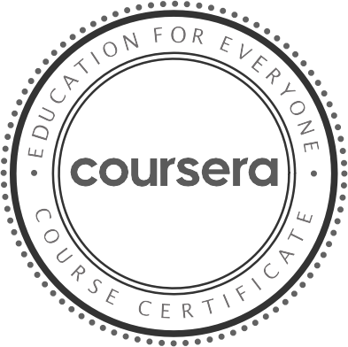

Ma y 29 , 2022

Rajesh R

has successfully completed

Interfacing with the Raspberry Pi

an online non-credit course authorized by University of California, Irvine and offered through Coursera

Ian Harris Professor

Department of Computer Science

Verify at: [https://coursera.org/verify/WZLVNE9D J93D](https://coursera.org/verify/WZLVNE9DJ93D)

Cour se r a ha s confir me d the ide ntity of this individua l a nd the ir

pa r t icipa t ion in the cour se .